
QUALITY ALERT

Customer: United Date: August 29, 2024
Die: 15144 Colour: Any
Type of Complaint: United REJECTED

Q.A # Q.I.R # CUSTOMER NCR #

Description: United REJECTED due to internal wall is too close, makes the reinforcement can’t go in
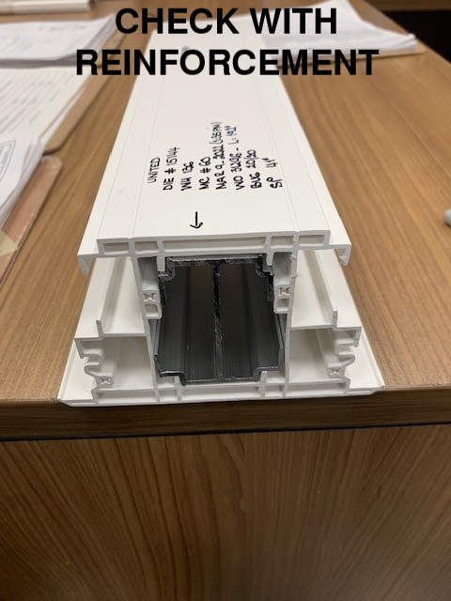
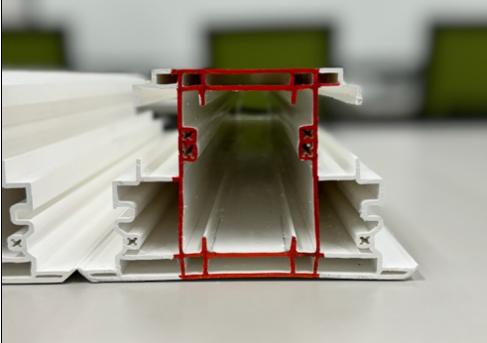
GAP TOO CLOSE

PLEASE MAKE SURE REINFORCEMENT FITS LOOSE BEFORE PACKING

BY SIGNING BELOW, YOU ACKNOWLEDGE THE PROBLEM ABOVE AND AGREE TO MONITOR THIS ISSUE IN FUTURE PRODUCTION RUNS.
DAY SHIFT |  | AFTERNOON SHIFT |  | NIGHT SHIFT
NAME | SIGNATURE | NAME | SIGNATURE | NAME | SIGNATURE

